eLearning Storyboard
Sheetmetal Laminate and Trim Course

Designer
Emily Correa

Security Marking
FOR OFFICIAL USE ONLY

Course Breakdown
The Sheetmetal Laminate and Trim course is an eLearning given during the Sheetmetal Academy portion of training for Groton, early in the training curriculum. Later, the learner’s career path includes laminate installation training in the Active Learning Center (ALC).
This training includes an introduction, 12 topics, and two knowledge checks.
Topics | Record  Number
A Focus on Sheetmetal Safety | 0100-TBD
A Deeper Dive into PPE Safety | 0200-TBD
Precautions | 0300-TBD
Lamination Tools | 0400-TBD
More Lamination Tools to Consider | 0500-TBD
Lamination Requirements | 0600-TBD
Why Are Proper Lamination Techniques Important? | 0700-TBD
Four Areas to Avoid | 0800-TBD
Additional Requirements | 900-TBD
Restraining Trim | 1000-TBD
The Lamination Process | 1100-TBD
Four Final Best Practices | 1200-TBD
Conclusion | 1300-TBD

Instructions for the Media Developer

Indicate which of the following should be included in this training:
Menu and bookmarking (required for all courses)
Forced navigation (Learner must complete Topics 1, 2, 3, etc. in order and returns to the menu to begin each new topic.)
Non-forced navigation (Learner can move throughout the course freely without any set order.)
Bookmarking (Learner can exit the course at any time and, upon returning to complete the course, the learner resumes from the same place exited. Note: Knowledge checks and quizzes must be completed before exiting, otherwise the learner will start at the beginning of the knowledge check or quiz.)
Level-2 quiz
Incorporated in this course (Complete quiz fields.)
None
New navigation buttons (if applicable)
- Name of new navigation button.
- New navigation button description and functionality.

Completion status sent to Learning Management System (LMS):
After successful completion of Level-2 quiz (based on criteria on next page or Page 1 of the quiz storyboard)
At end of course summary page
Graphics are demonstrated on the storyboard pages for layout and review. The file name is identified in the Media: box for the page.
Media Developer note: Graphic files are accessible at the following location.

Quiz Instructions for the Media Developer

Type of Level-2 Quiz
Non-randomized (default)
Randomized
Randomized with special pooling (If selected, provide details in the Additional Information section.)

Scoring (if applicable)
80% non-mastery (Score < 80% will show failed test result but will not affect successful completion of course.)
80% mastery (Score < 80% will show failed test result and course will not be marked completed.)
% non-mastery (Score < % will show failed test result but will not affect successful completion of course.)
% mastery (Score < % will show failed test result; course will not be marked completed and needs to be approved during solution design.)

All questions are weighted at one point each. If your project requires a different weighting, please discuss this with your training analyst and your media developer.

Feedback
Wrong answer feedback can provide correct answer explanation.
Wrong and correct answer feedback choices provide no explanation and use the generic template remediation.

Number of Tries
Unlimited (default)
Other (Remediation plan for limited number of tries needs to be approved during solution design.)

Number of Questions
total questions
after randomizing (if randomized quiz)

Estimated Duration
minutes

Special Reporting
No question-level reporting (default)
This quiz will need question-level reporting to the LMS

Additional information:

Course Title: Sheetmetal Laminate and Trim
Record# 0100 | Topic title: Sheetmetal Laminate and Trim | Page title: Welcome
Audio | Text on Screen | GFX/Programming Notes
Music: N/A  Narrator:  Welcome to the Sheetmetal Laminate and Trim course.  Click the Start button to begin. | Sheetmetal Laminate and Trim | Animation: N/A  Image file name:  Interaction:  The learner clicks Next to start.

Record# 0200 | Topic title: Objectives | Page title: Objectives
Audio | Text on Screen | GFX/Programming Notes
Music: N/A  Narrator:  This course is an introduction to sheetmetal laminate and trim.  Upon completion of this course, you will be able to:  - Define the requirements and proper techniques for laminate installation.  - Identify the personal protective equipment (PPE) required for installing for laminate installation and safety precautions.  - Identify the tools required.  Click Next to continue. | Objectives  This course is an introduction to sheetmetal laminate and trim.  Upon completion of this course, you will be able to:  - Define the requirements and proper techniques for laminate installation.  - Identify the personal protective equipment (PPE) required for installing for laminate installation and safety precautions.  - Identify the tools required.  Click Next to continue. | Animation: N/A  Image file name:  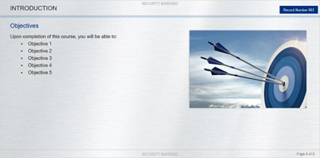  Interaction  The bullets come in one at a time, with the specific narration timed to each bullet.  The learner clicks Next to continue.

Record# 0300 | Topic title: A Focus on Sheetmetal Safety | Page title: Personal Protective Equipment (PPE)
Audio | Text on Screen | GFX/Programming Notes
Music: N/A  Narrator:  What are the seven common PPE items required for safety?  Click each circle to learn more. | What are the common seven PPE items required for safety?  Circle 1:  Hard Hat  Circle 2:  Safety Shoes  Circle 3:  Hearing Protection  Circle 4:  Safety Glasses  Circle 5:  Safety Gloves  Circle 6:  Respirators (at times, depending on the task)  Circle 7:  Grinding Face Shield | Media: Please build custom interactive. Replace the circles with the seven images in the Image Folder as a CUSTOM Captivate design.  Animation: Click to reveal.  Image file name:  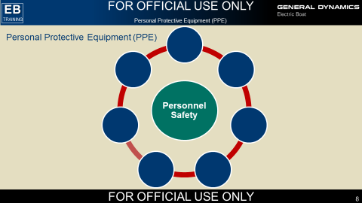  Interaction:  The learner clicks through each icon to reveal the text per click. After each icon is revealed, insert:  Click Next to continue.  The learner clicks Next to advance.
Record# 0400 | Topic title: A Deeper Dive in PPE Safety | Page title: Hard Hat, Safety Shoes, and Hearing Protection
Audio | Text on Screen | GFX/Programming Notes
Music: N/A  Narrator:  Let’s learn more about the seven common PPE items we use in the sheetmetal task: hard hats, safety shoes, hearing protection, safety glasses, safety gloves, respirators (at times, depending on the task, and grinding face shields.  Click each icon to learn more. | Let’s learn more about the seven common PPE items we use in the sheetmetal task: hard hats, safety shoes, hearing protection, safety glasses, safety gloves, respirators (at times, depending on the task) and grinding face shields.  Tab 1:  Hard Hat  - Hard hats must be Electric Boat approved.  - Your department may provide you with either a bump (low profile hat) or a hard hat.  - You must wear the hat with its brim facing forward.  - No ball caps are allowed under the hard hat.  Tab 2:  Safety Shoes  - Safety shoes must be Electric Boat approved.  - You must wear steel-toe shoes at all times in the shipyard.  - Specific Electric Boat trade groups are eligible to receive a tax-free reimbursement on a pair of safety shoes. Access the Electric Boat Safety Shoe Program for details.  Tab 3:  Hearing Protection  - Custom fit equipment may be provided as needed.  Tab 4:  Safety Glasses  - If you wear prescription glasses, the Optical Shop may provide a prescription for safety glasses.  - Custom fit glasses are available as needed.  - Several configurations of safety glasses are available.  Tab 5:  Safety Gloves  - Using safety gloves is key in keeping your hands safe.  - You must use gloves that are cut resistant.  - You may need nitrile gloves for some types of laminate installation task.  Tab 6:  Respirator  - This PPE item is required only at times, depending on the task.  - A respirator is frontline defense against occupational diseases caused by breathing contaminated air.  - All respiratory protective equipment used at Electric Boat must meet National Institute for Occupational Safety and Health (NIOSH) approval.  - You must qualify to wear a respirator by completing training, fit testing, and a medical exam.  Tab #7:  Grinding Face Shield  - A safety shield is required during all grinding work.  - You must wear a shield and safety glasses.  - The shield protects your face and eye areas from sparks or flying objects, which can harm you.  - Remember, safety is the number one priority at Electric Boat, but safety is your responsibility. | Media: Please build custom interactive. Create a custom box design of each PPE icon INSTEAD of the word of the item e.g. “Hard Hat,” and include with its accompanying notes. If it can be a matching game, even better!! Remember use the ICON/image NOT the word per icon!  Animation: Click to reveal  Image file name:  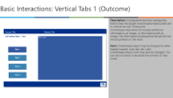  Interaction:  The learner clicks each icon to reveal the text bullets below.

Record# 0500 | Topic title: Precautions
Audio | Text on Screen | GFX/Programming Notes
Music: N/A  Course overview  Narrator:  It is important to be aware of certain precautions while installing laminate.  These precautions may prevent near-miss events, injury to personnel, or damage to equipment and materials from occurring on the job.  Click each tab to learn more. | It is important to be aware of certain precautions while installing laminate.  These precautions may prevent near-miss events, injury to personnel, or damage to equipment and materials from occurring on the job.  When Moving Laminate:  - When moving sheets of laminate, lift them up.  - Do not slide them.  - This prevents abrasions on the decorative faces.  When Providing Acclimation:  - Formica laminate must be allowed to adapt to the environment before installation.  - The ideal wait time before installation is 3 days.  - Failure to wait before installation can result in “stress cracking”.  Utilizing the Direction of the Grain:  - The longest section of Formica laminate should be cut in the direction of the grain.  - This reduces the chances of stress cracking.  The Amount of Adhesive:  - Use sufficient adhesive (as load and coverage).  Using Bonding Pressure:  - Be sure to use sufficient bonding pressure.  - The recommended pressure is 30 to 40 pounds per square inch (PSI).  Clean Surfaces:  - If the cleaning solution has not completely evaporated, the laminate will not adhere correctly.  - Use a cleaning solution that completely wipes off with a cloth or evaporates from the surface.  Miscellaneous:  - Keep in mind that metal core is a bit thicker than real Formica.  - Use the appropriate cutting tool when working with metal core.  - Use a knife or router to cut real Formica.  - Do not use a cutting wheel or shears.  Click Next to continue. | Animation: N/A  Media: Please expand the slider into two slides to fit all seven items or use the Tabs interaction.  Image file name:  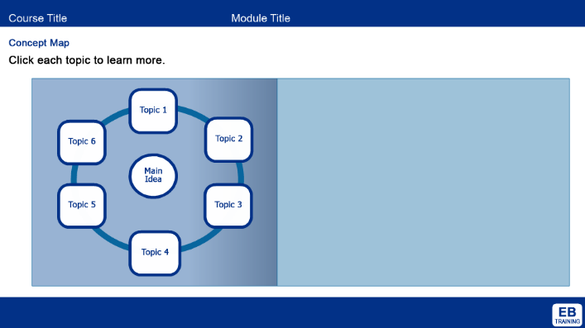  Interaction:  The learner can click through each circle tab, which features more information.

Record# 0600 | Topic title: Lamination Tools
Audio | Text on Screen | GFX/Programming Notes
Music: N/A  Narrator:  What lamination tools do we use at Electric Boat?  Drag each of the 11 tools to the correct toolbox.  When you finish, click Next to continue. | What lamination tools do we use?  - J-roller  - Circular saw  - Large sheer press  - Double-sided tape (includes thin double-sided tape)  - Straight edge  - Dynabrade  - Tape measure  - Jigsaw  - Cutting wheel  - Rivet gun  - Cleaning solvent | Animation: N/A  Media: Use the icons in the folder as part of this drag and drop.  Image file name:  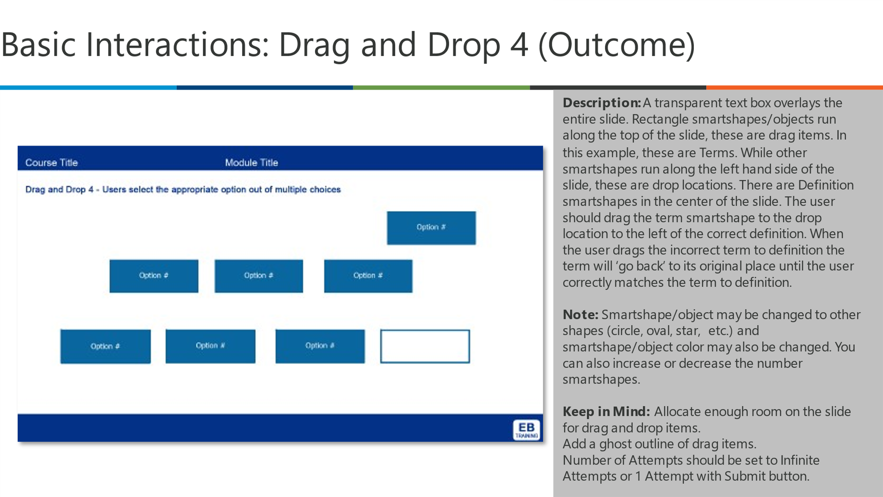  Interaction:  The learner drags each of the 11 tools and drags to a custom tool box.  They click next to go to the next screen.

Record# 0090 | Topic title: Knowledge Check #1 | Page title: Question 1
Audio | Text on Screen | GFX/Programming Notes
Music: N/A  Narrator: | Select the correct answer, and then click Submit.  Which of the seven common PPE items are missing from this list? Hard hats, safety shoes, hearing protection, safety gloves, respirators, and grinding face shields.  - Electric drill  - Work Boots  - Safety glasses  - Hopper | Animation: N/A  Image file name: N/A  Question type: N/A  Interaction:  The NEXT button is disabled until the learner has responded to the question and the course has displayed the feedback. After the learner submits a response:  - Provide the appropriate feedback.  - Enable NEXT.  - Display directional text.  Correct Answer: c. Safety Glasses  Correct Answer Feedback: Correct! Click anywhere to continue.  Incorrect Answer Feedback: That is incorrect. The correct answer is c. Safety Glasses  Click anywhere to continue.

Record# 0700 | Topic title: More Lamination Tools to Consider
Audio | Text on Screen | GFX/Programming Notes
Music: N/A  Narrator:  What are some more lamination tools we may use in our toolkit?  Drag each tool to the correct box. | Which lamination tools do we use in addition to the primary tools?  - Cutter bits (Freud 44-102 and Freud 28-100)  - Carbide or diamond tip blades  - Combination square  - Pencil (do not mark laminate with anything other than pencil)  - Masking or painters tape  - Dividers or trammel points  - Protective film EBPN 218074942  - Spacing sticks  - Dowels | Animation: N/A  Media: Use the icons in the folder as part of this drag and drop.  Image file name:  Interaction:  As the learner clicks each honeycomb, the extra tools are revealed one by one.  Note: Split items across two slides as applicable.  The slide auto-advances after each honeycomb is clicked.

Record# 0800 | Topic title: Why Are Proper Lamination Techniques Important?
Audio | Text on Screen | GFX/Programming Notes
Music: N/A  Narrator:  Why is it important to know the requirements for laminate installation?  They are important to know because they ensure:  - The task is done right the first time  - To keep workers safe  - To help prevent mistakes that can be costly for the task and the submarine  It is also important to consider the differences in requirements for different types of laminating materials.  Click each tab to learn more. | Why is it important to know the requirements for laminate installation?  They are important to know because they ensure:  - The task is done right the first time  - To keep workers safe  - To help prevent mistakes that can be costly for the task and the submarine  It is also important to consider the differences in requirements for different types of laminating materials. | Animation: N/A  Image file name:  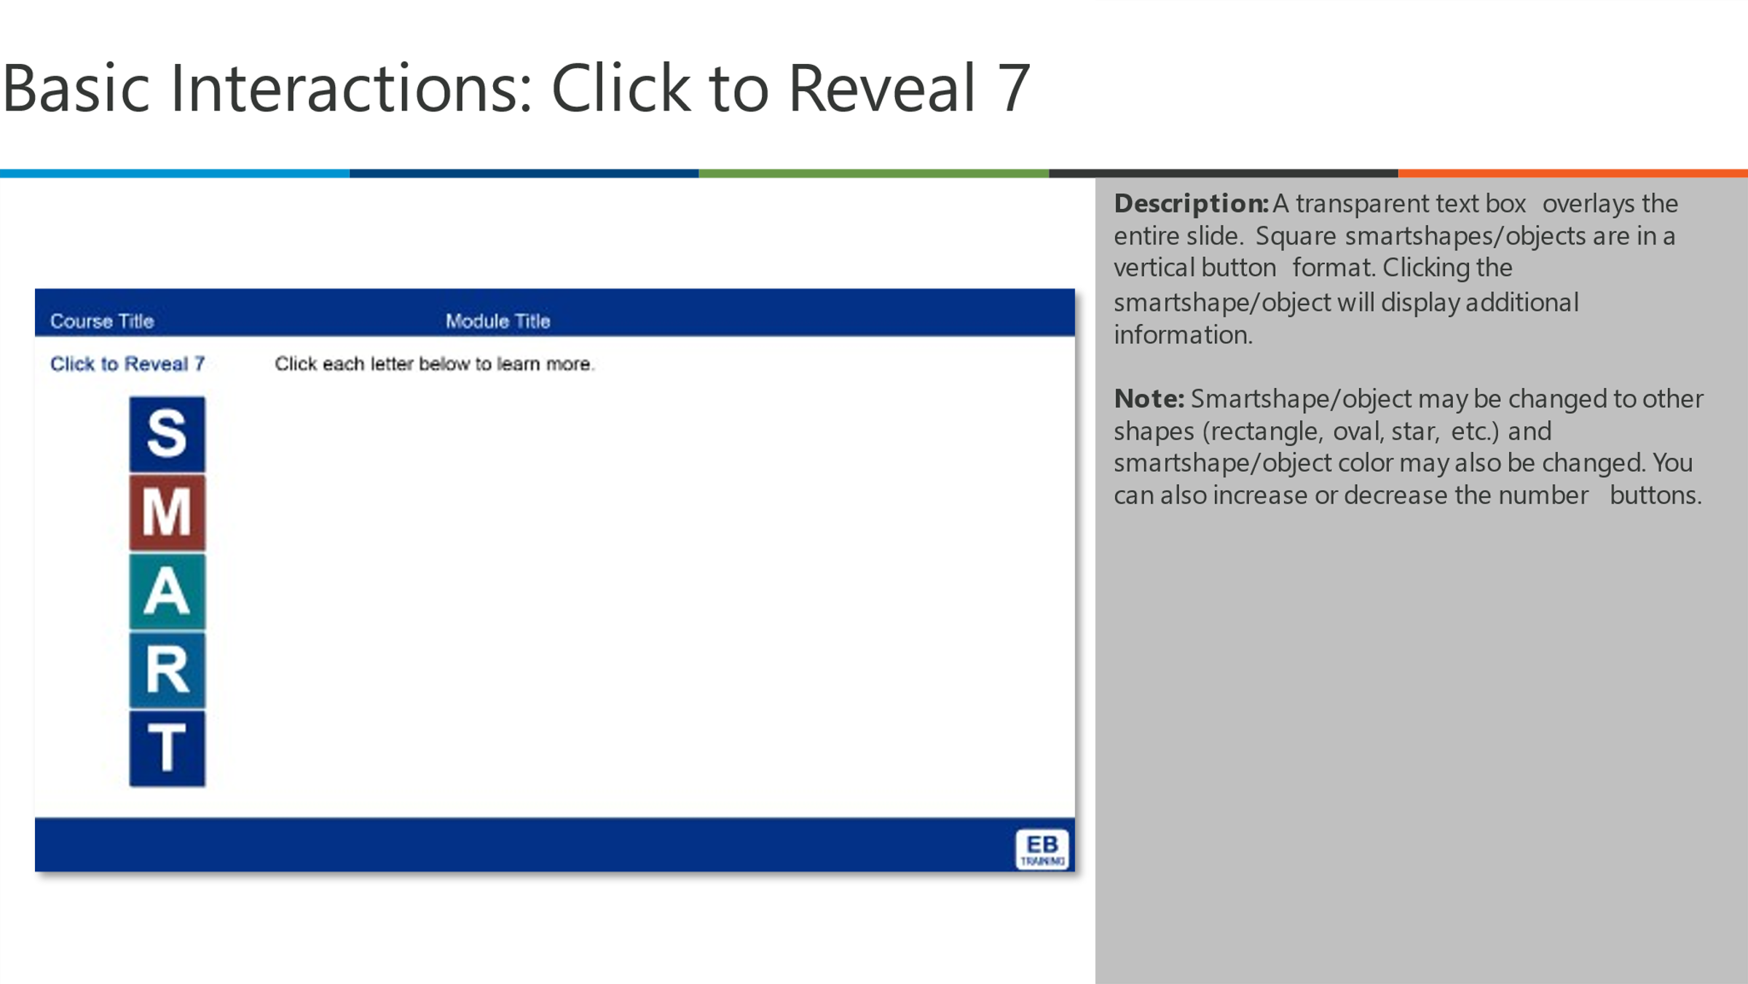  Interaction:  As the learner clicks each tab, the attributes are revealed one by one.  The slide auto-advances after each tab is clicked.

Record# 900 | Topic title: Four Areas to Avoid
Audio | Text on Screen | GFX/Programming Notes
Music: N/A  Narrator:  There are specific areas of the submarine where you cannot install laminate like damage control lockers, which are painted red to make them easily visible in emergencies.  Click each tab to learn more. | There are specific areas of the submarine where you cannot install laminate like damage control lockers, which are painted red to make them easily visible in emergencies.  Tab 1:  Gauges and mounted equipment  Tab 2:  Berth trays  Tab 3:  Polished Corrosion Resistant Steel (Cres)  Tab 4:  Damage control station lockers  Tab 5:  Emergency Air Breathing (EAB) lockers and doors | Animation: N/A  Image file name:  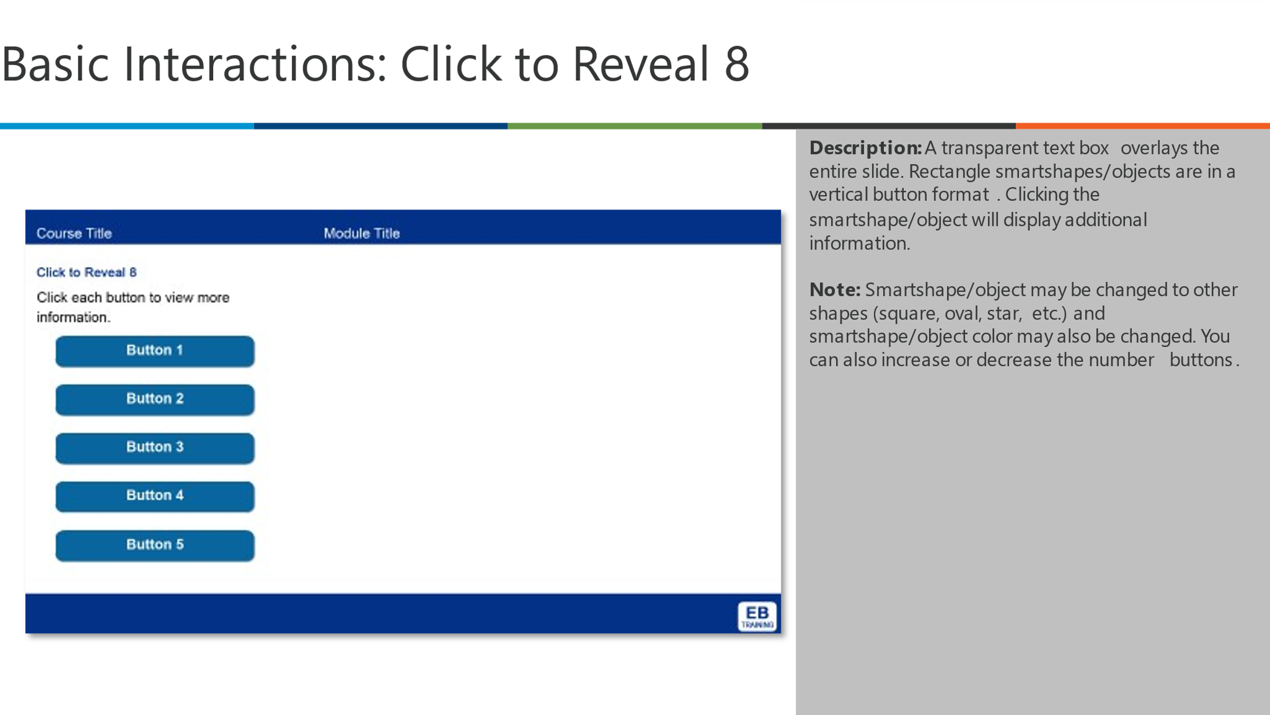  Interaction:  The learner clicks through each colored tab to reveal the text per click.  They click Next to advance the slide.

Record #0100 | Topic title: Knowledge Check #2 | Page title: Question 2
Audio | Text on Screen | GFX/Programming Notes
Music: N/A  Narrator: | Select the correct answer, and then click Submit.  The 4 areas to avoid for lamination include: Gauges and mounted equipment, Berth trays, Damage control station lockers and Emergency Air Breathing (EAB) lockers and doors.  - True  - False | Animation: N/A  Image file name: N/A  Question type:  Interaction:  The NEXT button is disabled until the learner has responded to the question and the course has displayed the feedback. After the learner submits a response:  - Provide the appropriate feedback.  - Enable NEXT.  - Display directional text.  Correct Answer: a. True  Correct Answer Feedback: Correct! Click anywhere to continue.  Incorrect Answer Feedback: That is incorrect. The statement is True. Click anywhere to continue.

Record# 1000 | Topic title: Additional Requirements
Audio | Text on Screen | GFX/Programming Notes
Music: N/A  Narrator:  Installing laminate is a precise task.  Click each tab to learn more about the requirements. | Installing laminate is a precise task.  Click each tab to learn more about the requirements.  Tab 1  Attachments and penetrations  Ensure all attachments and penetrations are complete before applying laminates.  Tab 2  Local areas  Use common materials that maintain a clean look to the space.  Uniformity  Each space must be uniform.  Tab 4  Bulkhead covering  When covering bulkheads, take care to ensure the grain pattern in adjoining pieces and is vertical.  Tab 5  Horizontal surfaces  Plastic laminate on horizontal surfaces should be applied lengthwise. | Animation: N/A  Image file name:  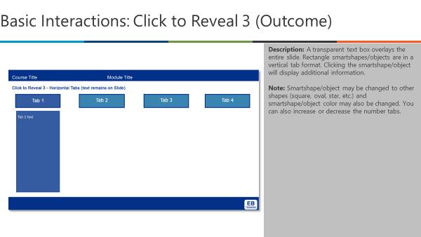  Interaction:  The learners clicks each tab to reveal the content before clicking next to go to the next slide.

Record# 1100 | Topic title: Restraining Trim
Audio | Text on Screen | GFX/Programming Notes
Music: N/A  Narrator:  Let’s look at where to install restraining trim on the boat.  Click each of the 7 areas to learn more. | Let’s look at where to install restraining trim on the boat.  Click each of the 7 areas to learn more.  Circle 1:  In all corners  Circle 2:  At the tops of laminated panels  Circle 2:  Around openings  Circle 4:  At the bottoms of laminated panels where cover molding is omitted  Circle 5:  On exposed edges that are subject to wear  Circle 6:  In the seams or gaps of the plastic laminate | Animation: N/A  Image file name:  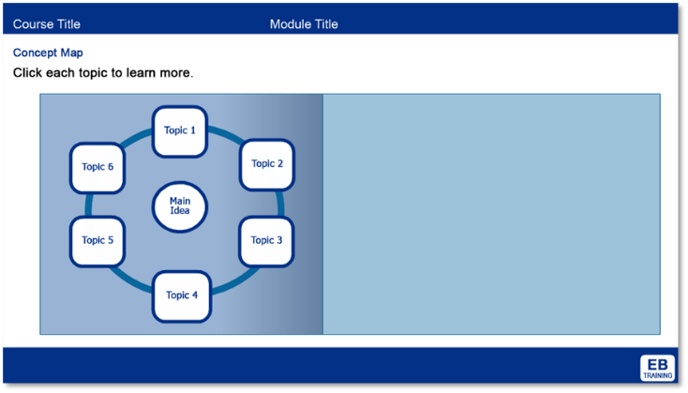  Interaction:  Learners will click through to learn more.

Record# 1200 | Topic title: The Lamination Process
Audio | Text on Screen | GFX/Programming Notes
Finally click each of the 10 steps to review the lamination process. | Finally click each of the 10 steps to review the lamination process.  Step 1: Record the appropriate measurements for the piece of laminate you need to install.  Step 2: Retrieve the correct piece of laminate and verify it against the drawing and applicable requirements.  Step 3: Cut the laminate to the appropriate size, taking care to cut the type of edge necessary for the best finish.  Step 4: If necessary, use a Dynabrade fine-tooth mill file to clean up the edges.  Step 5:  - Thoroughly clean the laminate and surface with either a disinfectant spray or a glass cleaner.  - Use Lysol® disinfectant spray or Windex® glass cleaner.  - Clean the back of the laminate and the surface where the laminate will be installed.  Step 6:  - If you are applying tape to doors, you must use thinner tape.  - The laminate will not fit if you use regular tape.  - Apply double-sided tape, ensuring there are no air bubbles.  - A best practice is to add a piece of double-sided tape every 3 to 4 inches, not to exceed every 6 inches.  Step 7: Apply adhesive in two layers to the back of the laminate, letting it dry “open time.”  Step 8:  - When the adhesive is still wet, you can apply the laminate.  - After you have applied the second layer of adhesive, wait until the adhesive is almost dry.  - You can then apply the laminate.  Step 9: Roll a laminate roller or J-roller back and forth across the laminate, applying even pressure.  Step 10: If necessary, install rivets in the trim surrounding the laminate. | Animation: N/A  Media: Note: There is a VERBAL NARRATION PER STEP HERE. Split all 10 items across 4 slides if need be! Images in folder.  Image file name:  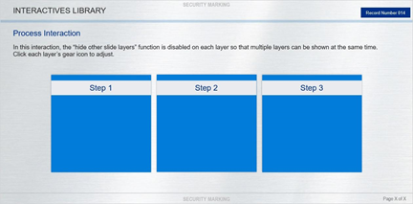  Interaction:  The learner clicks through each tab to reveal a narration and text per click. They click next to advance the slide.  NOTE: Create a clickable “bonus” with the following information.  Important: When you are applying a large piece of laminate, place spacing sticks or dowels between the material and the laminate.  - This helps ensure there are no air bubbles between the laminate and the material you are applying it to.  - After applying the second layer of adhesive, let it dry until it is nearly tacky but not completely dry, and then apply the laminate.

Record# 1300 | Topic title: Four Final Best Practices
Audio | Text on Screen | GFX/Programming Notes
Music: N/A  Narrator:  These are a few best practices to remember. | These are a few best practices to remember.  As you work with:  A cutting wheel  - Use a finished edge.  Shears  - Use a non-finished edge.  A jigsaw  - Use a non-finished edge, typically for an interior cut such as a “window in a door”.  - Use a fine-tooth blade with the “face side” of the Formica down. | Animation: N/A  Image file name:  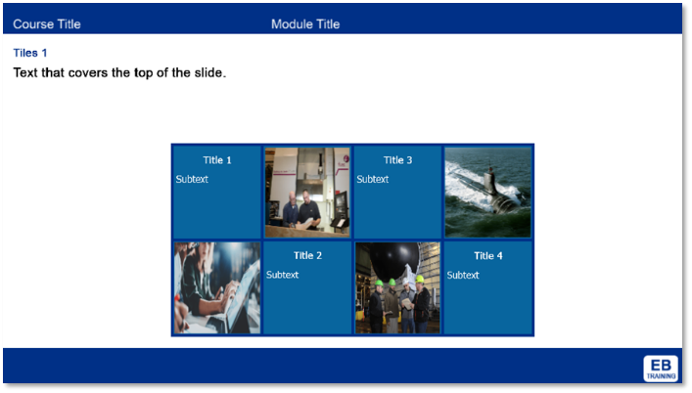  Interaction:  The learner clicks through each tab text per click. They click Next to advance the slide.

Record #1400 | Topic title: Course Completion
Audio | Text on Screen | GFX/Programming Notes
Music: N/A  Narrator:  Congratulations! You have successfully completed the Sheetmetal Laminate and Trim course.  Close this window to record the completion in the learning management system (LMS). | Congratulations! You have successfully completed the Sheetmetal Laminate and Trim course.  Close this window to record the completion in the learning management system (LMS). | Animation: N/A  Image file name: N/A  Interaction: N/A

Record# 1500 | Topic title: Conclusion
Audio | Text on Screen | GFX/Programming Notes
Music: N/A  Narrator: | You have completed the course.  Close this window to record the completion in the LMS. | Animation: N/A  Image file name: N/A  Interaction: N/A

Resources
Material in this course was adapted, modified, and reproduced with permission as appropriate from the following resources:
- FOUO_FG_LaminateInstall_102820_FNL.docx

